Data flow diagram(DFD) for Online shopping website

A data flow diagram is a graphical view of how data is processed in a system in terms of input and output.  
The Data flow diagram (DFD) contains some symbol for drawing the data flow diagram.

Data flow diagram symbol

|  |  |
| --- | --- |
| **Symbol** | **Description** |
| [dfd symbol](https://meeraacademy.com/wp-content/uploads/2016/09/arro.jpg) | **Data Flow** – Data flow are pipelines through the packets of information flow. |
| [dfd process](https://meeraacademy.com/wp-content/uploads/2016/09/process.jpg) | **Process :**A Process or task performed by the system. |
| [dfd entry symbol](https://meeraacademy.com/wp-content/uploads/2016/09/Entity.jpg) | **Entity :**Entity are object of the system. A source or destination data of a system. |
| [dfd source symbol](https://meeraacademy.com/wp-content/uploads/2016/09/source.jpg) | **Data Store :** A place where data to be stored. |

Context level DFD – 0 level

The context level data flow diagram (dfd) is describe the whole system. The (o) level dfd describe the all user module who operate the system. Below data flow diagram of online shopping site shows the two user can operate the system Admin and Member user.

[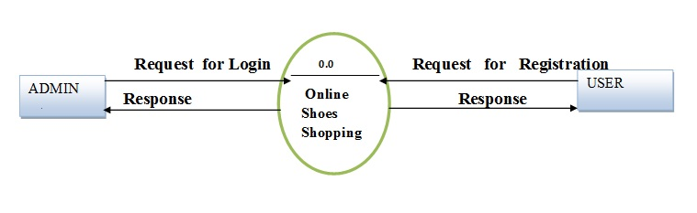](https://meeraacademy.com/wp-content/uploads/2016/09/olevel.jpg)

o – Level DFD for Online shopping website project

1st Level Admin  Side DFD

The Admin side DFD describe the functionality of Admin, Admin is a  owner of the website. Admin can first add category of item and then add items by category wise. and admin can manage order and payment detail.

[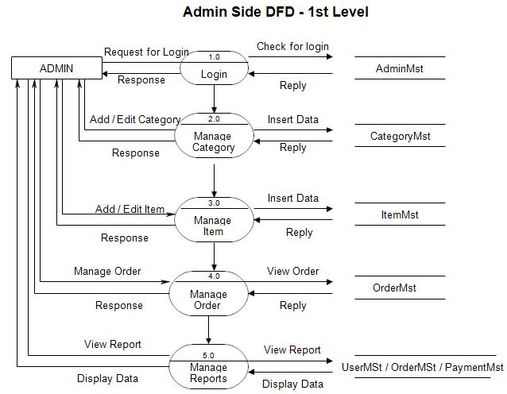](https://meeraacademy.com/wp-content/uploads/2016/09/adminside-first.jpg)

1st Level – Admin Side Data Flow Diagram

2nd Level – Admin side DFD (3.0)

[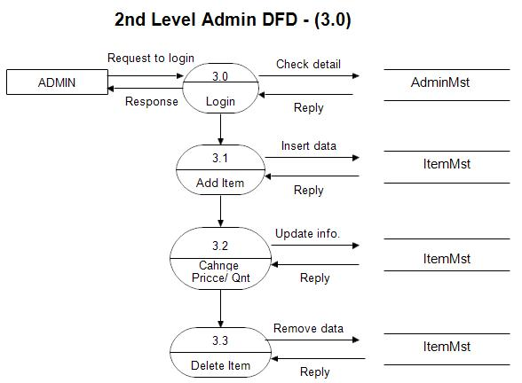](https://meeraacademy.com/wp-content/uploads/2016/09/admin3.0.jpg)

DFD for online shopping website project

2nd Level – Admin side DFD (4.0)

[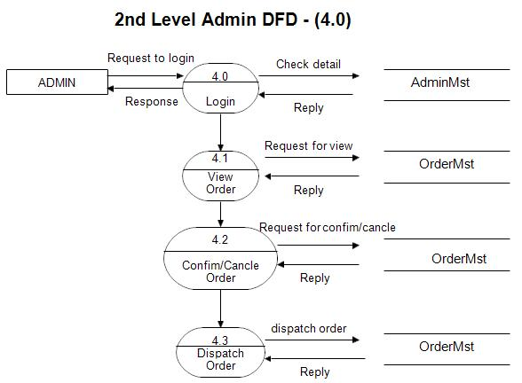](https://meeraacademy.com/wp-content/uploads/2016/09/admin4.0.jpg)

Admin side DFD for online shopping website project

2nd Level – Admin side DFD (5.0)

[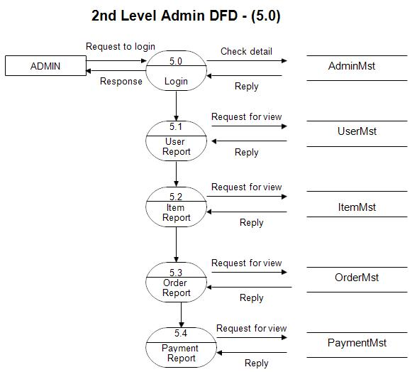](https://meeraacademy.com/wp-content/uploads/2016/09/admin5.0.jpg)

Admin side DFD for online shopping website project

1st level – User side Data flow Diagram

The user is all people who operate or visit our website. User is a customer of a website. User can first select product for buy, user must have to register in our system for purchase any item from our website. after register he can login to site and buy item by making online payment through any bank debit card or credit card.

[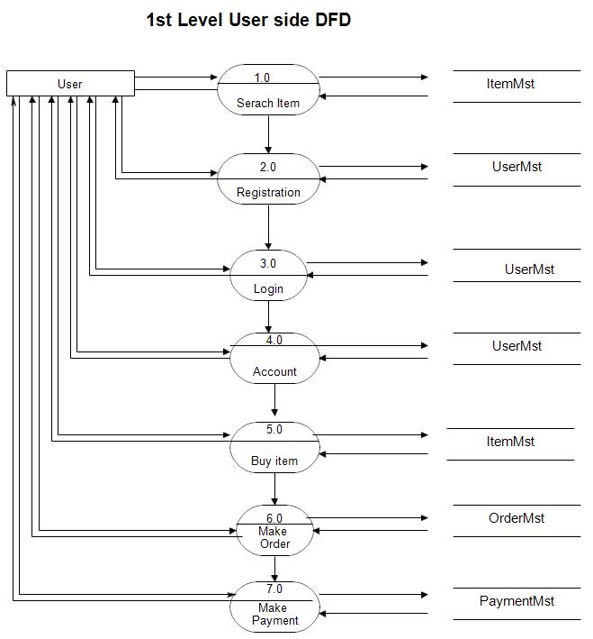](https://meeraacademy.com/wp-content/uploads/2016/09/user1st.jpg)

User side DFD for online shopping website project

2nd level – User side DFD (4.0)

[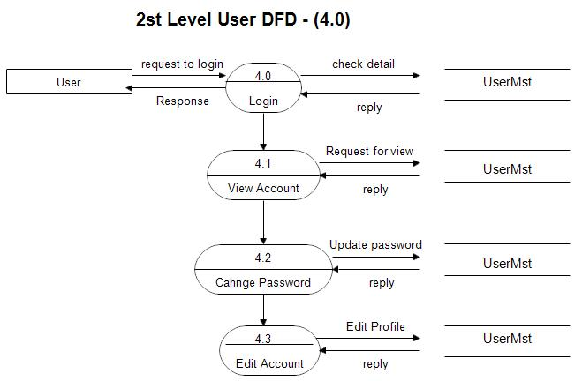](https://meeraacademy.com/wp-content/uploads/2016/09/usr4.0.jpg)

User side DFD for online shopping website project

2nd level – User side DFD (5.0)

[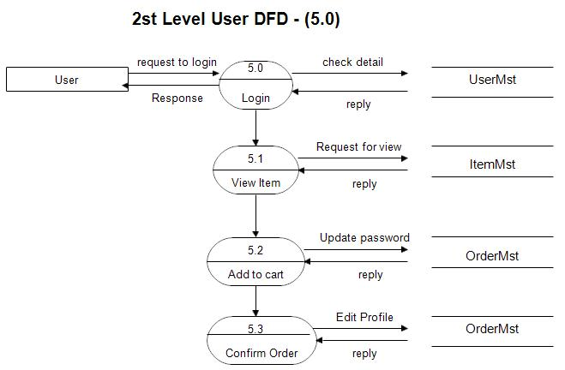](https://meeraacademy.com/wp-content/uploads/2016/09/usr5.0.jpg)

DFD for online shopping website project

## Data flow diagram for food ordering system

A data flow diagram is a graphical view of how data is processed in a system in terms of input and output.  
The Data flow diagram (DFD) contains some symbol for drawing the data flow diagram.

Context level DFD for Online food system

[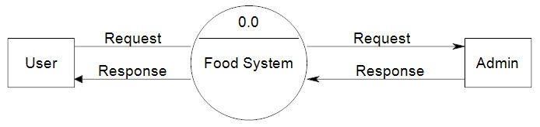](https://meeraacademy.com/wp-content/uploads/2016/09/fooddfd0.jpg)

dfd for online food ordering system in asp.net project

1st level DFD for User

[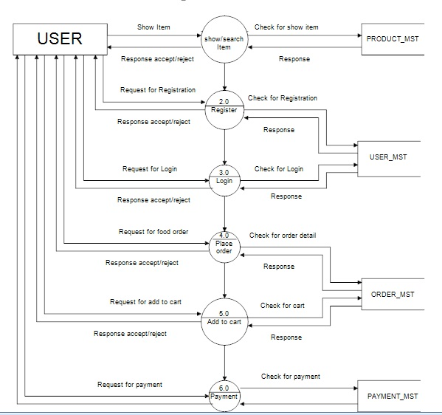](https://meeraacademy.com/wp-content/uploads/2016/09/fooddfd1user.jpg)

dfd for online food ordering system in asp.net project

2nd level DFD for user (3.0)

[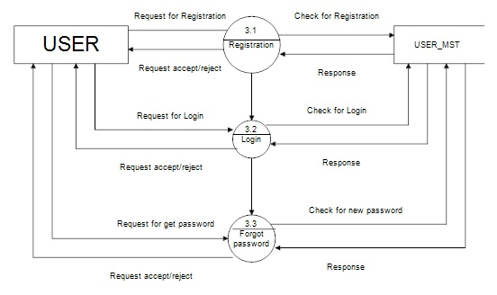](https://meeraacademy.com/wp-content/uploads/2016/09/fooddfd2user.jpg)

dfd for online food ordering system in asp.net project

Admin side DFD for online food system

[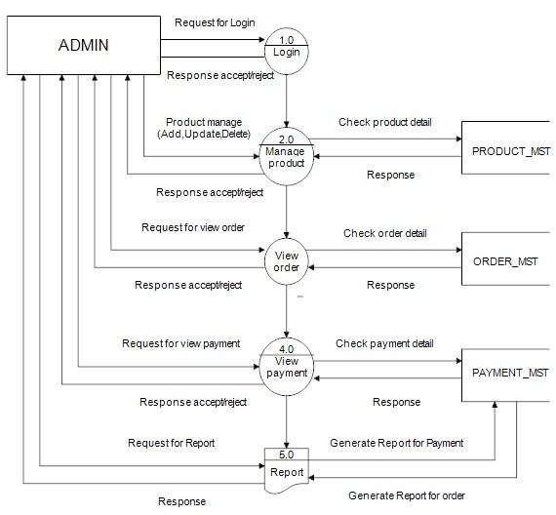](https://meeraacademy.com/wp-content/uploads/2016/09/food1admin.jpg)

dfd diagram for online food ordering system

## Data flow diagram(DFD) for Online shopping website

Context level DFD – 0 level

The context level data flow diagram (dfd) is describe the whole system. The (o) level dfd describe the all user module who operate the system. Below data flow diagram of online shopping site shows the two user can operate the system Admin and Member user.

[](https://meeraacademy.com/wp-content/uploads/2016/09/olevel.jpg)

o – Level DFD for Online shopping website project

1st Level Admin  Side DFD

The Admin side DFD describe the functionality of Admin, Admin is a  owner of the website. Admin can first add category of item and then add items by category wise. and admin can manage order and payment detail.

[](https://meeraacademy.com/wp-content/uploads/2016/09/adminside-first.jpg)

1st Level – Admin Side Data Flow Diagram

2nd Level – Admin side DFD (3.0)

[](https://meeraacademy.com/wp-content/uploads/2016/09/admin3.0.jpg)

DFD for online shopping website project

2nd Level – Admin side DFD (4.0)

[](https://meeraacademy.com/wp-content/uploads/2016/09/admin4.0.jpg)

Admin side DFD for online shopping website project

2nd Level – Admin side DFD (5.0)

[](https://meeraacademy.com/wp-content/uploads/2016/09/admin5.0.jpg)

Admin side DFD for online shopping website project

1st level – User side Data flow Diagram

The user is all people who operate or visit our website. User is a customer of a website. User can first select product for buy, user must have to register in our system for purchase any item from our website. after register he can login to site and buy item by making online payment through any bank debit card or credit card.

[](https://meeraacademy.com/wp-content/uploads/2016/09/user1st.jpg)

User side DFD for online shopping website project

2nd level – User side DFD (4.0)

[](https://meeraacademy.com/wp-content/uploads/2016/09/usr4.0.jpg)

User side DFD for online shopping website project

2nd level – User side DFD (5.0)

[](https://meeraacademy.com/wp-content/uploads/2016/09/usr5.0.jpg)

DFD for online shopping website project

## Data Flow Diagram – Hospital Management System

Context level DFD – 0 level

The context level data flow diagram (dfd) is describe the whole system. It shows the all user module who operate the system. The Hospital management system data flow diagram shows there is only one user hospital admin staff to run the system.

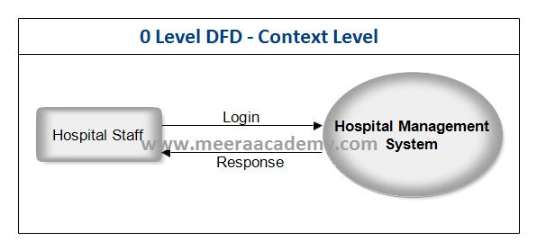

DFD 0 Level – Hospital Management System

1st  Level DFD  – Hospital Management System

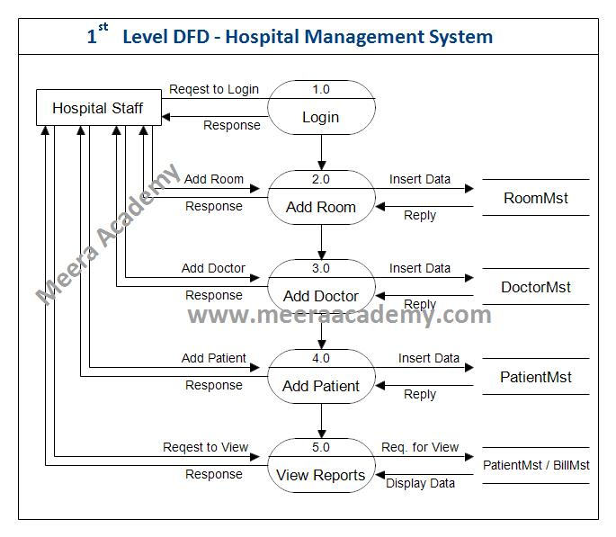DFD 1 Level – Hospital Management System

2nd Level DFD (2.0) – Hospital management System

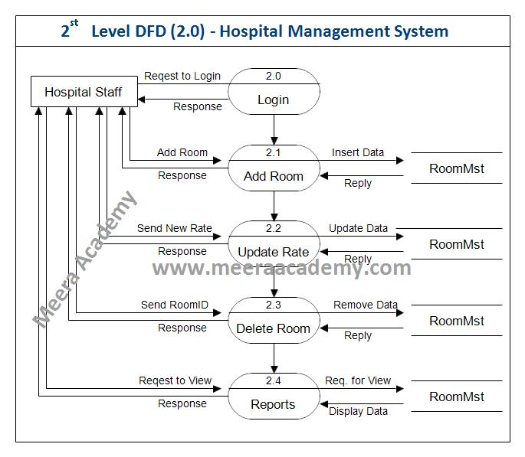DFD 2nd Level (2.0) – Hospital Management System

2nd Level DFD (3.0) – Hospital management System

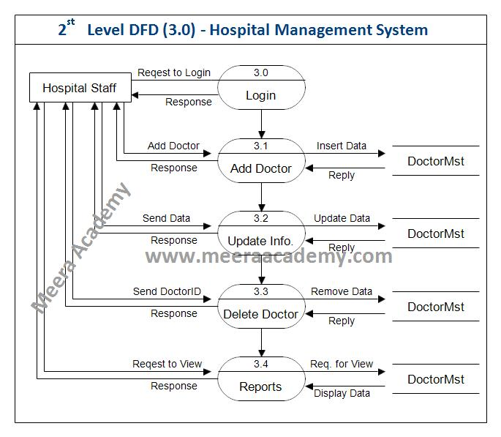DFD 2nd Level (3.0)- Hospital Management System C#.Net Project

2nd Level DFD (4.0) – Hospital management System

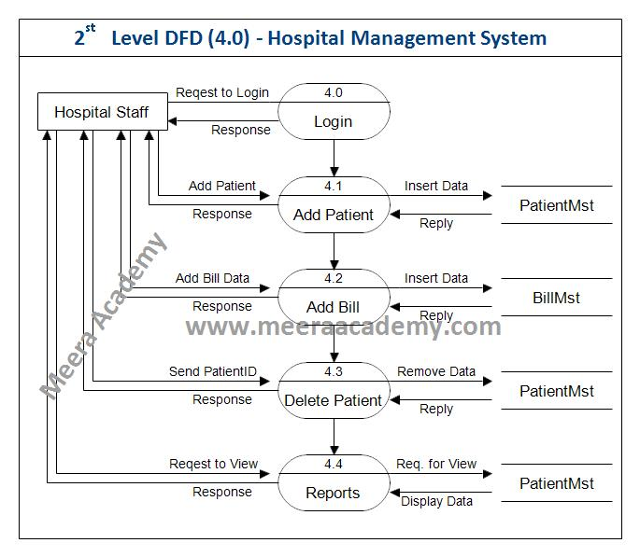DFD 2nd Level (4.0) – Hospital Management System

2nd Level DFD (5.0) – Hospital management System

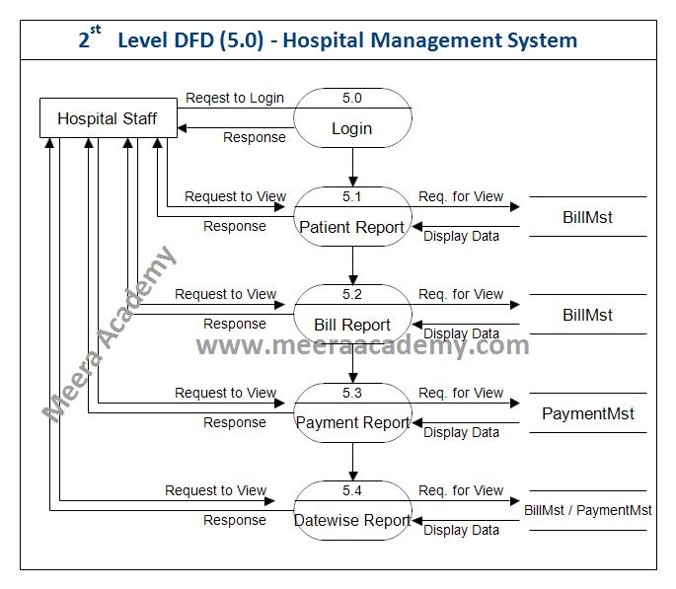DFD 2nd Level (5.0) – Hospital Management System

3rd Level DFD (4.2) – Hospital management System

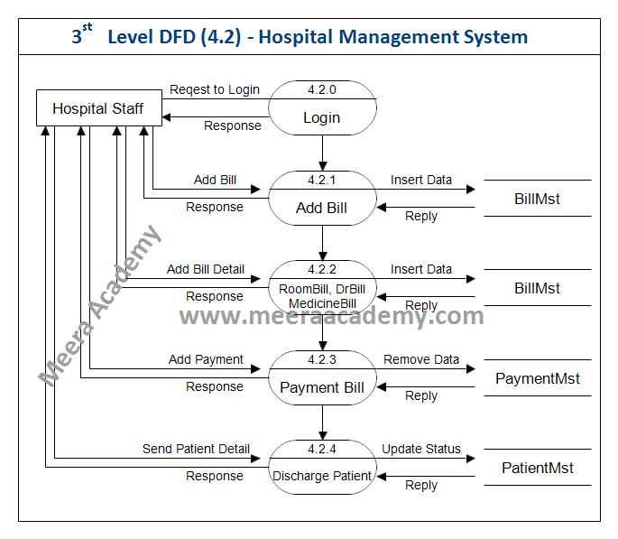DFD 3rd Level (4.2) – Hospital Management System

## Data Flow Diagram for Online Teaching Project

Context Level Diagram (0 level DFD)

The context level data flow diagram (dfd) is describe the whole system. The (o) level DFD describe all user module who operate the system. Below data flow diagram of online teaching website shows the three user can operate the system Admin, Teacher and Student.

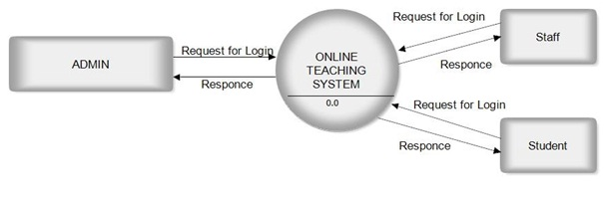

DFD for Online Teaching Project

Admin Side DFD

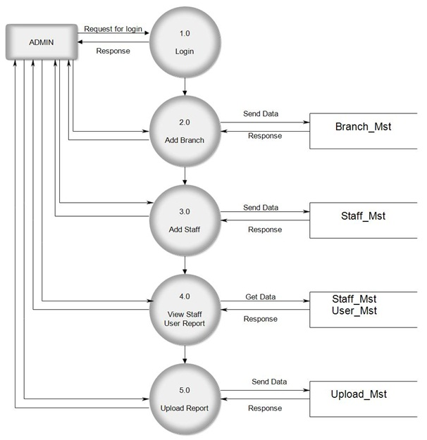

Admin Side DFD for Online Teaching Project

Teacher Side DFD

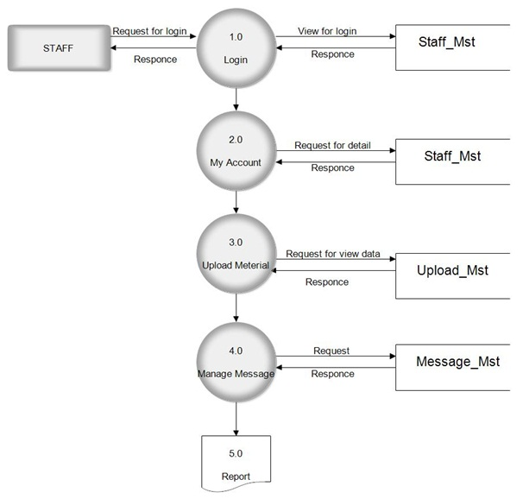

Teacher Side DFD for Online Teaching Project

Student Side DFD

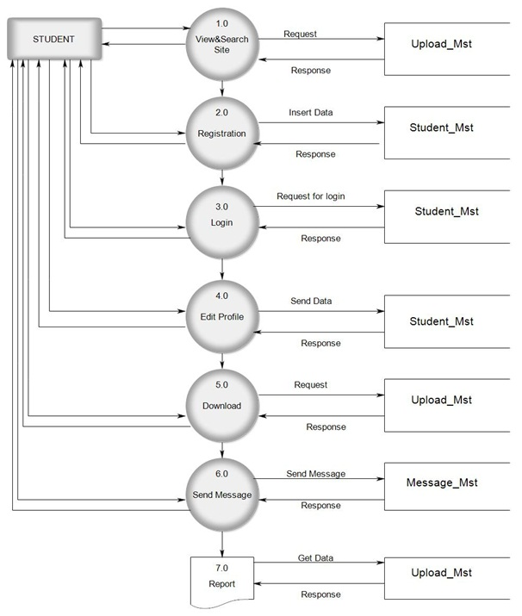

Student Side DFD for Online Teaching Project

<https://meeraacademy.com/dfd-diagram-for-online-shopping-website/>

<https://meeraacademy.com/dfd-diagram-for-student-management-system-project/>